First Go program

1. Create a directory

***mkdir chap1***

***cd chap1***

1. Create a module

***Go mod init hello_world***

* A Go project is called a module, it’s not just source code, it’s also an exact specification of the dependencies of the code within the module
* Every module has a go.mod file in its root directory
* Running go mod init creates this file for us

***module hello_world***

***go 1.20***

* go.mod file declares the name of the module, the minimum supported version of Go for the module & any other modules that your module depends on

→ Similar to the requirements.txt file in Python or Gemfile in Ruby

* We shouldn’t edit the go.mod file directly (we have to use ***go get*** & ***go mod tidy*** commands)

1. Create a go file

***code hello.go***

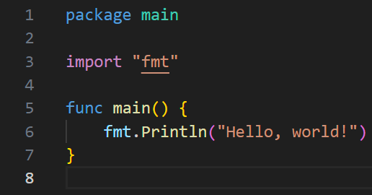

1. Create an executable : go build

***go build hello.go***

* Creates an executable in the current directory
* If we run it (***./hello***) : ***Hello, world !*** will be printed in the command line
* ***Go build -o*** : if we want a different name for our application or store it in a different location
* **Go build -o Hello_world**